**Library Management System**

**Project Report**

**Project Details:**

* Project Title: Library Management System
* Name for the Website: Integrated Library Management System for UTD.

**Project Description**:

We have designed and developed an online Library Management System that can be integrated by standalone libraries or school /university libraries for better access of library resources through a website. We have included resources such as books, e-books and movies.

This system has an admin portal through which an admin can give access rights such as student, faculty or staff to newly registered user as well as add, update, edit and delete the above mentioned items. The admin also has the ability to check-in an item upon return from a user.

We have the user side of the website that enables user to sign up in the system and registered users to view a dashboard which summarizes their cart, wish list, fines and general activities on the website. They can search for an item in the entire library database, as well as perform search for individual type of items and perform an advanced search based on name and category of the item. A registered user can add these items to his/her cart and proceed to checkout. In addition to that, the items can also be added to a wish list. The users can also view the list of borrowed items, their cart, wish list and the fines that have been imposed upon late return of any items. User has an option to remove items from cart and wish list.

All the input fields of the web pages contain validation to accept valid data and functional validations.

**Database Design**

This web application uses relational database (MySQL) hosted on google cloud servers. Database create table scripts are attached with report to get insides of database design.

**Languages/frameworks used for implementation**

HTML5, Bootstrap CSS, JQuery, Ajax, PHP, MySQL hosted on Google Cloud

**Screenshots for Main Functionalities:**

1. **Admin Pages**

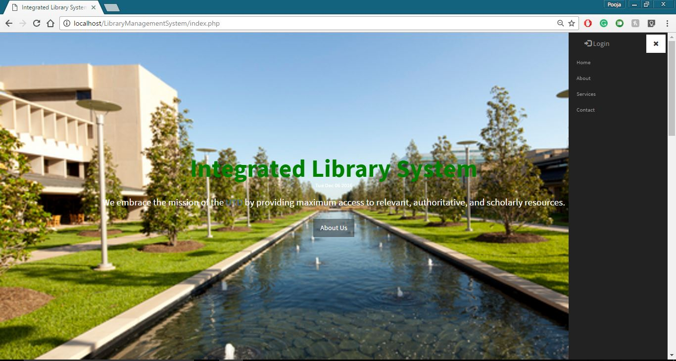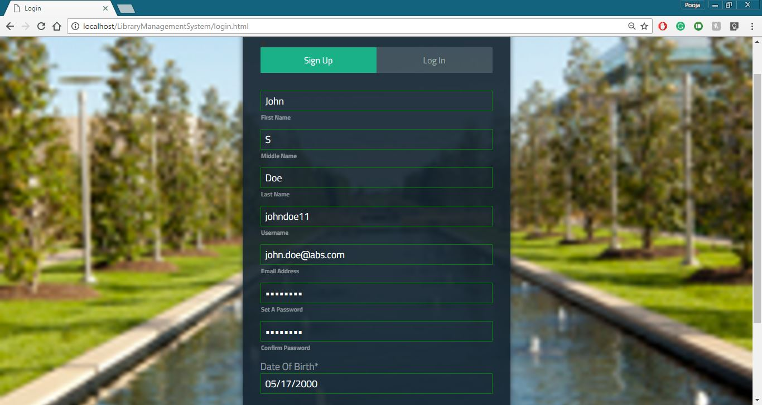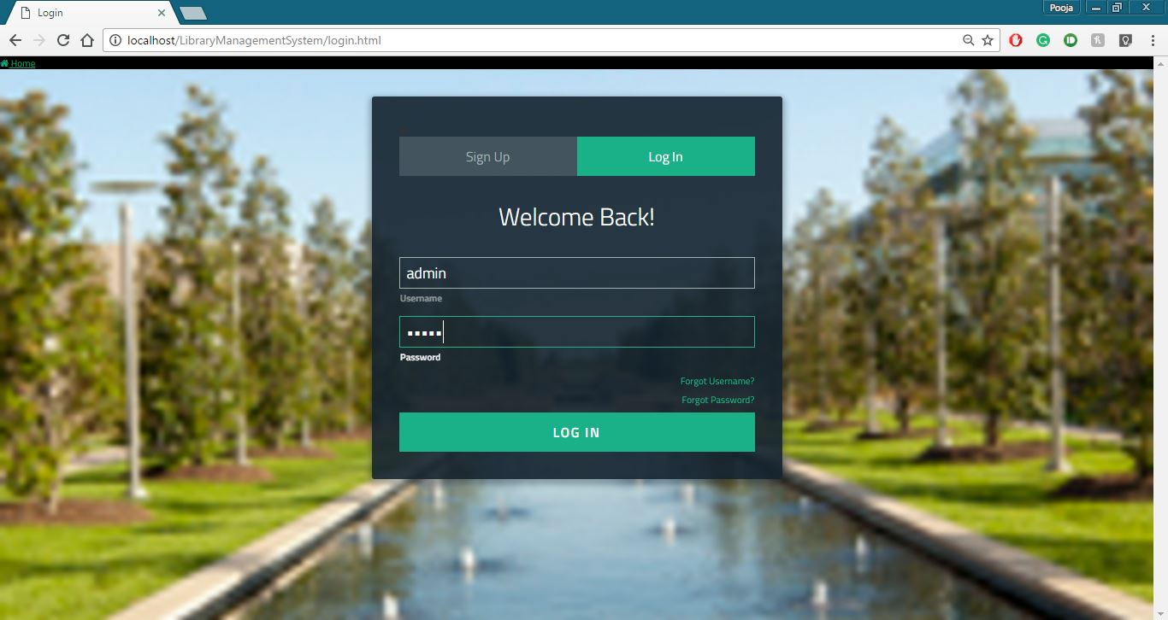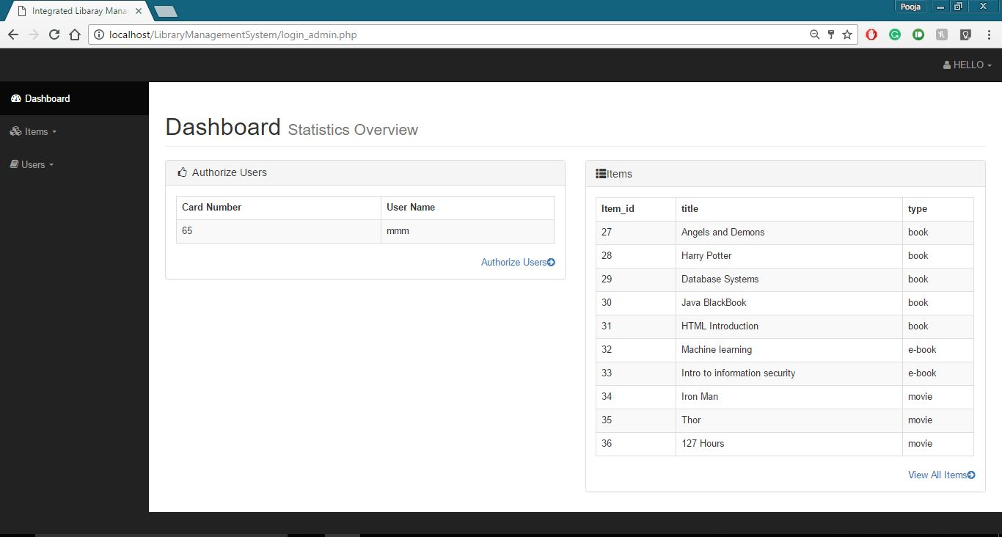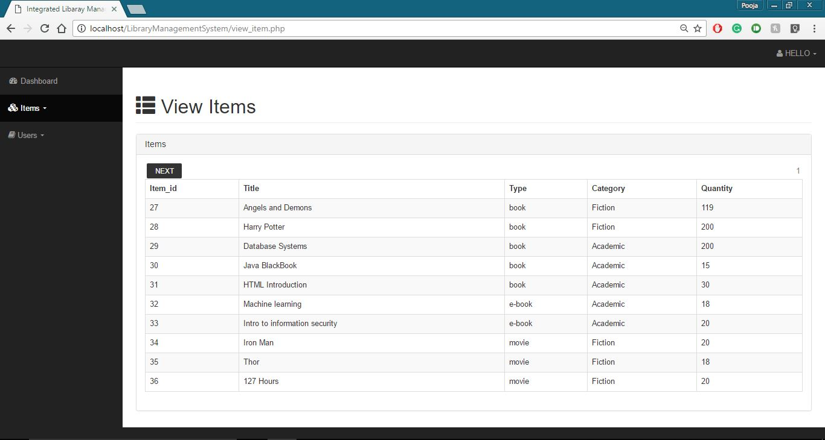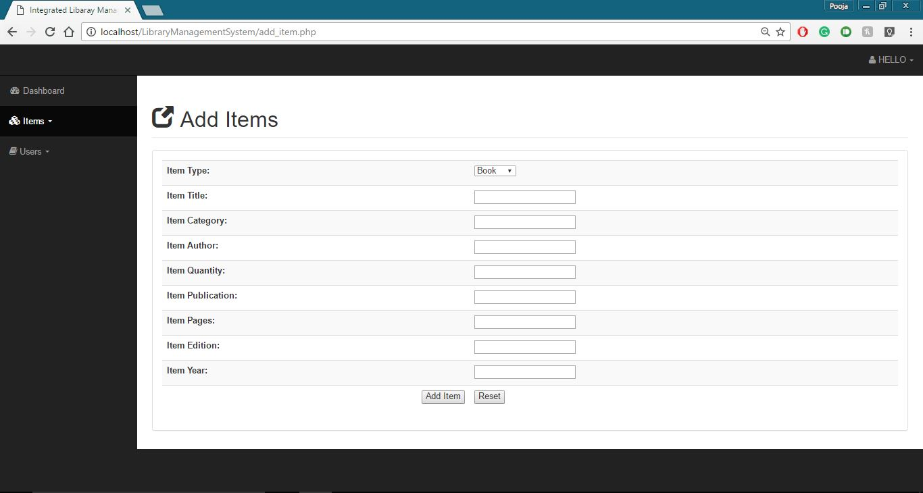

1. **User Pages**

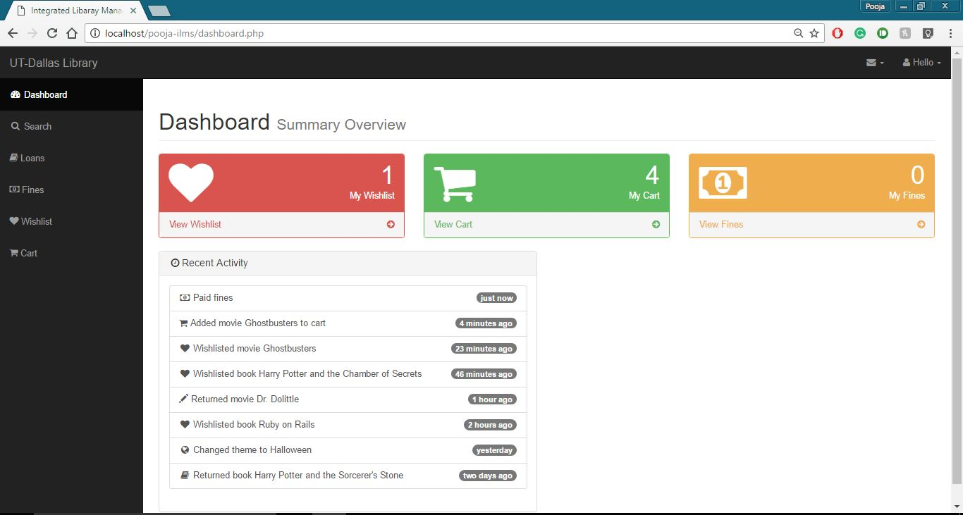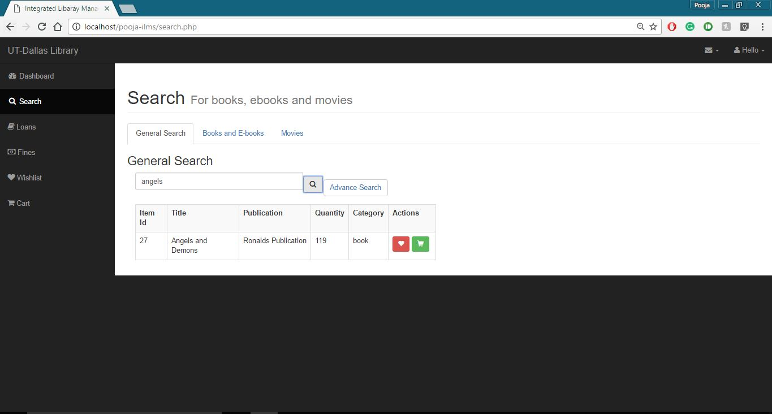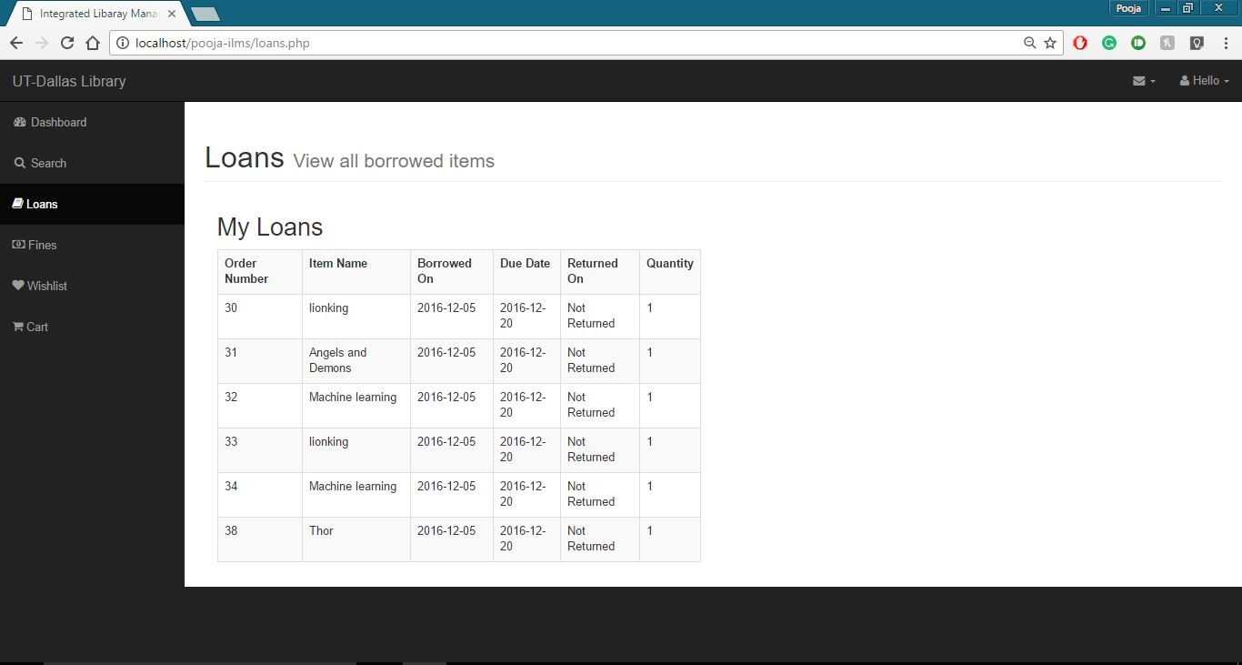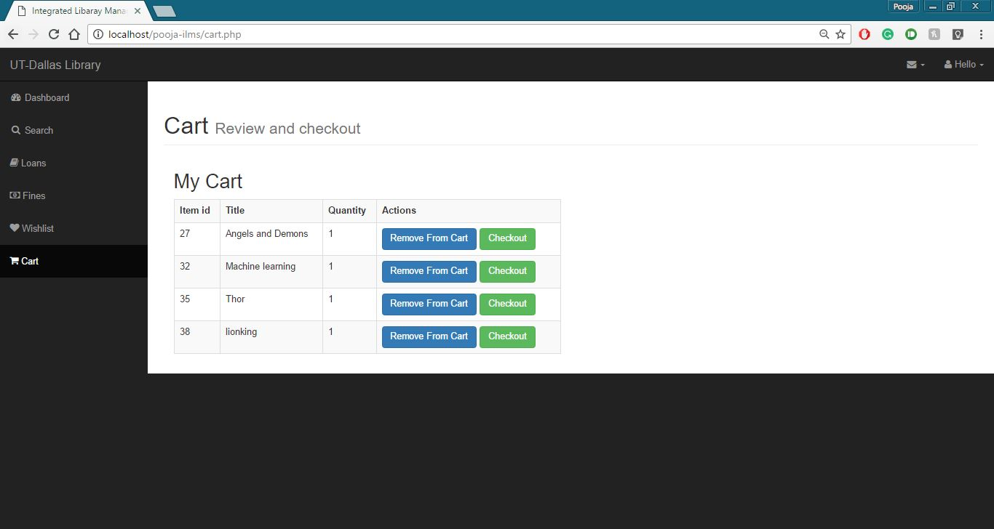

**Team Members: Names and Net-IDs for team members**

Himanshi Aggarwal, hxa152730

Nilesh Pharate, nxp161330

Pooja Junnarkar, psj150130

**Work division among team members**

This application has been results of a team work and each member of team worked on each area of development including user interface design, styling of pages, validations and client side scripting, server side scripting and services and database design and management.

**Individual Roles**

1. **Himanshi Aggarwal**

Himanshi worked on admin dashboard design. She developed pages for item add, update and delete tasks for admin. Along with Nilesh, she has worked on server side scripts for these tasks. She also worked on database design and creation as well as test data creation for unit testing of application. Along with Pooja, she worked on advanced search on user dashboard. She also worked on server side code for item checkout by user, item check in by admin and handling late check ins and fine creation logic for same.

1. **Nilesh Pharate**

Nilesh worked on design and styling of user sign up page. He also developed client side validation and error handling for invalid data on sign up form. This includes existing user checking using ajax call and password strength checking and hashing. He was part of database design and creation task. He also worked on user authentication and approval by admin task. He worked on handling server side script for user sign up and also developed server side code for user approval by admin. Along with Pooja, he worked on server side code for basic search of items on user dashboard.

1. **Pooja Junnarkar**

Pooja has worked on design and styling part of user dashboard. She has worked on client side validations and page design for search, advanced search, cart, loans, fines and wish list pages. She was also part of database design task. She has developed server side code for cart and wish list update. Pooja was also responsible to design user transaction summary page along with its server side code for displaying user current loans, fines, cart and wish list in a summarized way. Along with Himanshi, she has been part of advanced search for item task.